Create a React Application named “officespacerentalapp” which uses React JSX to create elements, attributes and renders DOM to display the page.

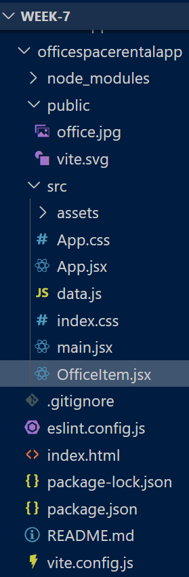

**data.js:**

export const officeList = [

  {

    Name: "DBS",

    Rent: 50000,

    Address: "Chennai",

    Image: "/office.jpg"

  },

  {

    Name: "Regus",

    Rent: 70000,

    Address: "Bangalore",

    Image: "/office.jpg"

  },

  {

    Name: "WeWork",

    Rent: 55000,

    Address: "Mumbai",

    Image: "/office.jpg"

  }

];

**OfficeItem.jsx:**

import React from "react";

import "./index.css";

const OfficeItem = ({ item }) => {

  const colorClass = item.Rent <= 60000 ? "textRed" : "textGreen";

  return (

    <div style={{ marginBottom: "30px" }}>

      <img src={item.Image} width="200px" height="200px" alt="Office Space" />

      <h1>Name: {item.Name}</h1>

      <h3 className={colorClass}>Rent: Rs. {item.Rent}</h3>

      <h3>Address: {item.Address}</h3>

    </div>

  );

};

export default OfficeItem;

**App.jsx:**

import { useState } from 'react'

import './App.css'

import OfficeItem from "./OfficeItem";

import { officeList } from "./data";

function App() {

  const heading = "Office Space";

  return (

    <div style={{ textAlign: "center" }}>

      <h1>{heading} , at Affordable Range</h1>

      <div className="office-list">

        {officeList.map((item, index) => (

          <OfficeItem key={index} item={item} />

        ))}

      </div>

    </div>

  );

}

export default App;

**index.css:**

.textRed {

  color: red;

  font-weight: bold;

}

.textGreen {

  color: green;

  font-weight: bold;

}

.office-list{

  display: flex;

  align-items:flex-start;

  justify-content:center;

  flex-wrap:wrap;

  gap:20px;

  padding: 10px;

}

**Output:**

